Repression, Group Threat, and the Threat Environment

Peter D. Carey II
PhD Candidate
Department of Political Science
University of California, Merced

Abstract:
How do governments contend with multiple sources of dissent? The Law of Coercive Responsiveness tells us that governments respond to threats to the status quo with repression, but this does not explain how governments choose to spend their limited resources when there are multiple targets. To answer this question, I extend our understanding of “dissident threat.” In addition to the two latent dimensions of Group Demand and Group Capacity that the literature has identified, we also need to consider the larger universe of threats, the threat environment, when assessing the government’s repressive responses. Using a game-theoretic model, I demonstrate how the government’s repressive decisions are a function of the threat posed by the targeted group and the threat posed by the other groups around it. I then use the MAROB dataset to demonstrate this relationship empirically, showing that the threat posed by other groups has a significant influence on the government’s allocation of repression.

Introduction
Over the summer of 2020, the United States saw a nationwide wave of protest in response to the death of George Floyd at the hands of Minneapolis, MN police. These protests, which were part of the larger Black Lives Matter (BLM) movement that had begun years earlier, included a large mix of protesters, counter-protesters, and police. During these protests, BLM protesters and pro-police counter-protesters often clashed, with police responding to these clashes with repression. However, the police response to disruption at these protests seemed to be selective in how and to whom they were applying their repressive resources. Offenses that resulted in warnings for counter-protestors yielded arrests for BLM protesters; it was clear that officers would bend the rules for certain protesters, while coming down harshly on others.
We see myriad examples of differential policing throughout the United States during this period. Amnesty International (2020) and Chenoweth and Pressman (2020) collected and catalogued a great deal of these events; prominent examples include protests in Salem, OR, Portland, OR, and New York, NY. In Salem, there are numerous allegations of differential treatment by police. Black Lives Matter protesters allege that they were tailed by police in full tactical gear while visibly armed Proud Boys at the same protest were monitored by lightly armed police on bicycles. This is a trend that occurred throughout protests in Salem, with BLM protesters being trailed and harassed by SWAT teams while armed, drunk, and rowdy Proud Boys able to gather without police interference (Woodworth and Barreda 2020). In Portland, federal agents were observed travelling around protests in unmarked vans, abducting people observed protesting with the BLM group (Ward 2020). In New York, police were observed kettling protesters to ensure they were out after curfew, allowing them to use force (Human Rights Watch 2020); contrast this with police in Salem giving the Proud Boys advice on how to avoid arrest if they were out after curfew (Woodworth and Barreda 2020). How can we explain the difference in response across groups? How can we explain which group or groups the government meets with repression and which groups they choose to ignore?
According to the Law of Coercive Responsiveness (Davenport 2007), governments repress in response to threats to the status quo. Since the BLM protesters were out in large numbers, they might have been seen as threatening. This does not, however, explain the relatively slight attention the counter-protesters received. While there were not as many counter-protesters out on the streets as there were BLM protesters, those who were out were armed and willing to use violence (Chenoweth and Pressman 2020), suggesting they also posed a threat. To answer this question, then, we require an in-depth investigation into dissident “threat” – how governments perceive threat and how they weigh the threat posed by one group against the threat posed by another.
This paper proceeds as follows. In the next section, I discuss the scholarly literature on dissident threat. In particular, I focus on how definitions of threat differs and the latent dimensions that seem to underly the differing definitions: Group Demand and Group Capability. I then extend this definition of threat to include not just the target group but all the other groups that desire to impose some change on the government: the government’s threat environment. Using the concept of the threat environment, I investigate how the government weighs threats against each other and decides where to invest its scarce time and resources. I then utilize a formal model to illustrate how the presence of other groups influences the government’s repressive decisions. Governments compare the demands and capacities of the groups against one another, ensuring that any repression a group receives is a function of its own threat and the threat posed by other groups. Finally, I use the model to generate several empirical hypotheses and test them using data from the Minorities at Risk Observational Behavior (MAROB) dataset (Wilkenfield, Asal, & Pate 2011). The results demonstrate that governments do consider other groups when setting their repressive priorities, and the characteristics of these other groups have differential effects on the government’s use of repression. Increasing the number of strong, capable groups in a country causes the government to try to spread repression around, while increasing the number of groups with extreme demands only matters when these groups have the power to enforce their demands.

Threat in the Literature
One of the most consistent findings of the repression-dissent literature is that governments respond to dissident threats with coercion. This is such a truism that the “law of coercive responsiveness” (Davenport 2007) receives a mention in almost every political science article written on repression. But what goes in to “dissident threat”? How does the state decide what groups are “threatening” enough to warrant repression? How does the state pick its repressive targets?
Much of the literature sidesteps this question by assuming that the leaders are dealing with existential threats: either the repression succeeds and the dissidents back down, or they are faced with the possibility that they are removed from office. For example, one of the key findings from Ritter (2014) is that the use of repression is contingent on regime stability: the more secure leaders feel in their position, the less likely they are to use political repression. This logic is echoed by several scholars (Regan & Henderson 2002; Young 2013; Christensen & Weinstein 2013; Escriba-Folch 2013; Ritter and Conrad 2016; Heffington 2021), and it makes intuitive sense: regimes should be threatened by movements that seek to topple them. However, repression gets used on dissidents who are seeking less extreme demands than regime change (Koren & Mukherjee 2021). Clearly, there must be something threatening about these groups that doesn’t depend on their ability to overthrow the regime.
Although often implicit, there are two latent dimensions underlying the current conceptualization: group demand and group capacity. Using these dimensions, we can break down the concept of “threat as regime change” and understand why authors find that governments use repression on groups with less extreme goals. First, consider a group’s demand – the goal they are working towards achieving. On the extreme end, we have a group that wants to replace the current regime. This threat can manifest in several ways (i.e., the leader having concerns over the type of exit they will make (Escriba-Folch 2013), concerns over what will happen to them after they are removed from office (Conrad & Ritter 2013, Ritter 2014), etc.), but the underlying factor here is that the group’s demand, if achieved, upsets the status quo.
Existing research finds that status quo maintenance as the reason behind government repression (Earl, Soule, & McCarthy 2003; Pierskalla 2010; Davenport, Soule, & Armstrong 2011; DeMeritt 2016), and we can see implicit calls for this in the literature that uses deviations from the cultural norm as a measure of threat (see, for example, Davenport 1995). The general underlying logic is that group demands represent changes to the status quo power structure, which the government wants to defend. At the extreme, the status quo the government is trying to maintain is their leadership position, tying this dimension in with the literature on repression as a response to stability threats. However, any changes to the status quo are negative, as they represent an erosion of the power structures that put the current government in charge (Earl, Soule, & McCarthy 2003; Davenport, Soule, & Armstrong 2011; Davenport & Inman 2012; Chang & Vitale 2013). The changes are not all equally negative – changing a few policies is less threatening than regime change – so these groups should experience different levels of dissent. It should also be noted that threat is subjective to the government: similar demands might get different responses depending on the government (Chang & Vitale 2013).
The second dimension of threat in the current literature is group capacity. We can see this dimension implicitly invoked when authors refer to the tactics group use, their membership, and their organizational capacity (Davenport 1995; Moore 2000; Carey 2010; Danneman & Ritter 2014). This dimension revolves around the group’s ability to coerce the government into meeting its demands: Does it have the ability to generate enough costs on the government to make switching policies a less costly alternative? This makes intuitive sense when paired with the demand dimension. Groups may espouse extreme demands, but without the capacity to coerce the government these demands can be written off (Pierskalla 2010). This dimension covers everything from the group’s ability to get “boots on the ground” (Davenport 1995; Carey 2010) to their ability to learn from others and incorporate tactics that have worked before and ignore ones that failed (Danneman & Ritter 2014).
These two dimensions—a group’s intent to disrupt the status quo and their capability to do so—are useful for understanding when governments will expend scarce resources to repress dissident groups. However, there are aspects of repression that cannot be explained by these dimensions alone. Theoretically, if a group’s demand and capability remained constant, we should expect the government’s response to be constant as well. Empirically, however, this is not the case – we observe the government’s repressive response to a group change over time, sometimes within a matter of days or weeks. This could be evidence of an initial miscalculation on the part of the government – perhaps their information about the group’s capabilities and/or demand was incomplete, and once they made contact by attempting repression, they were able to update this information and their response. This is a reasonable explanation for some of the cases, but it can’t be representative of all of them: some states have impressive intelligence apparatuses that are used to gather important information on group demand and capability before they can dissent, and even these governments change their repressive strategies over time (Cunningham 2005). The answer lies outside of the threat characteristics of any one group; rather, we can explain these changes in repression by looking at the wider universe of groups – the threat environment.

The Threat Environment
The literature often assumes, for the sake of convenience, that repression-dissent interactions are dyadic: a government represses a group, that group dissents against the government, and the interaction ends. While the assumption that these interactions take place in a vacuum has helped to streamline theory and narrow interactions down to basic elements, this simplifying assumption runs the risk of misattributing the reasons for both changes in the government’s strategy and the group’s response. In reality, both the government and dissident group operate in a broader threat environment that is made up of all the existing and potential groups that the government may have to contend. All the groups in the threat environment have their own demands, their own capacity, and each pose a distinct threat to the government. Since repressive resources are not infinite, the government must weigh the benefits of repressing the target group right now against the possibility of not being able to stop the next group.
This threat environment changes the strategic calculus considerably. The government must now consider the demands and capacities of the other groups in the environment when crafting their response to the target group. Expending too many resources on repressing the target group may get them back down but leaves the government open to other threats. Focusing too much on other potential threats may stop dissent from cropping up in the future but does nothing to address the current problem. Changes in the threat environment, then, can explain shifting government policies towards groups; even if the group and the government stay the same, groups entering and exiting the threat environment change the government’s strategic calculus, changing their repressive policy as a result.
Returning to the US 2020 example, we can look at the “threat” posed by both the BLM protesters and right-wing counter-protesters, how the government may perceive this threat, and how these threats relate to one another to gain insight into why the police may have acted as they did. On the first dimension, Group Capability, one could argue that both groups were robust. The BLM protests saw large turnout, with some saying that they may be the largest protests in US history (Buchanan, Bui, and Patel 2020). If size is a valid measure of capability, which the literature suggests, then BLM would rank highly. The counter-protesters, on the other hand, did not have the benefit of size. Most counter-protests were smaller than their inciting protests, and events organized by right-wing groups did not see the attendance of the main BLM protests. However, size is not the only measure of capability – prior research has also considered tactics, organization, and willingness to use violence. The counter-protesters would score well on all these dimensions: they often represented organized groups like the Proud Boys, were often visible armed, and were willing to use violence (Chenoweth and Pressman 2020). As such, we might rank these counter-protesters highly on the threat dimension as well.
Where these groups differ, however, is on the demand dimension. The BLM protesters were advocating for significant changes to the status quo policies regarding policing and security, with some protesters advocating for the complete restructuring of the policing apparatus from the ground up. Considering the government uses the police to defend their power, these sorts of demands might be seen as extremely threatening – they threaten the ability of the regime to protect itself. The counter-protesters, on the other hand, were (mostly) pro-regime, with the rallying cry of some of these protesters being “Blue Lives Matter.” These dissidents were trying to perpetuate a status quo that they, and the regime, benefitted from. With this in mind, we can start to see why the police would focus on one threat versus another: while both groups may have been equally capable, the extreme demands of the BLM protesters, relative to the status quo, led the government and its agents to focus more of their repressive attention on them rather than on the counter-protesters. By comparing the characteristics of these two groups, governments were able to decide how to best distribute their repressive resources and respond to the threat posed by both groups.

A Model of Repression and the Threat Environment
To illustrate the logic behind the threat environment, I create a formal model. In this model, a pair of dissident groups are making decisions about whether to act, and the government is trying to figure out how best to use its repressive resources. Since its repressive resources are limited, the government may not have enough to repress both groups to the point where they back down. As such, the government is forced to weigh the threat posed by each group, in the form of their demands and capacities, and decide how best to invest in repression. The model demonstrates that, when the government has an abundance of repressive resources, it will repress with impunity. However, as the resources available to it dwindle and eventually become scarce, the government begins to carefully consider the threats posed by the different groups. Using various comparative statics derived from the model, I find that the repression faced by a group is a function of the threat posed by the other group – in particular, the other group’s demand and capacity interact to influence the likelihood of the government investing in repressing the target group fully.

The State of the System
This model looks at the interaction between three actors: a government, and a pair of dissident groups that I call the active/target group and the potential/other group. The government has some status quo policy that it derives benefit from and would like to maintain. The active group, on the other hand, would like to change the status quo and enact their preferred policy. The members of the latent group would also like to change the government’s status quo policy, albeit in a different way, but first need to mobilize before they can mount a challenge. In this interaction, the government first sets its level of reactive and preventive repression from its limited budget, then the active group decides whether to dissent or back down, and finally the latent group decides whether to attempt mobilization. This means that the outcome of the interaction has a great deal of variability. If the government can successfully get the other groups to back down, the interaction ends with the status quo maintained. Otherwise, the interaction ends in conflict, with the active group dissenting and/or the latent group attempting to mobilize.

The Government
The first of the main actors in this interaction is the government. I use the term “government” as shorthand for any political regime currently in power – the “government” actor is whoever currently controls the state. The government actor for any given state may change over time – when a regime is replaced, that new regime would be considered the government actor by my model. These regimes share one key trait, however: they all value the status quo. The status quo represents the current structure that allowed them to rise to and maintain power (Earl et al. 2003; Davenport et al. 2011); as such, they value the status quo remaining intact and deviations from the status quo are all negative. Larger changes to the status quo hurt more than minor ones, but they all hurt.
The government uses the resources at its disposal to protect the status quo through repression. The government can employ deterrent repression against the active group, raising the costs it faces, or employ preventive repression against the potential group, influencing its ability to mobilize. In this model, the government has the option to use one or both tactics – it can choose to only employ preventive repression, only employ reactive repression, or set some combination of both. The government’s allocations to each type of repression are subject to a resource constraint: the government has a set budget it can spend on repression, and each dollar it invests in reactive repression is one less that it can invest in preventive repression. As a result, the government faces a trade off in any given interaction – does it want to invest more in dealing with the group in front of it at the expense of potential further dissent down the line, or does it allow the current group to operate with relative impunity so it can quell latent dissent?
While assuming that all governments similarly value the status quo is useful for understanding how governments allocate repressive resources on average, this simplification impacts what I can say about the relationship between individual governments and individual dissident groups. The relationship between a government and a group depends on that government and the nature of the status quo; a different status quo may result in the same group being seen differently. The government might find the same group’s demand to be more or less extreme depending on the current status quo. While this may be the case, this simplification does not reduce my ability to speak to the main dynamic of interest: the interaction between a government and a group that wants to change the status quo under the threat of further potential dissent.

The Active Dissident Group
The second main player is a dissident group that is assumed to be active at the start of the interaction. This means that before this interaction began, this group solved the collective action problem, formalized its demands, and can make a claim on the government. The group has one decision to make: it can either dissent, challenging the government in the hopes that it can change the status quo, or it can back down and preserve the status quo. If it chooses to dissent, it enters a lottery where the group has a chance of getting their demand or a chance of being defeated and having the status quo prevail.
While the group’s probability of victory is exogenously determined in this model, we could think of it as a function of the group’s capabilities: their resources, manpower, organizational structure, etc. As the group increases in capabilities, the probability that it can successfully challenge the government increases – making it more likely that the group will see its policy demand met. The group knows that if it attempts to dissent, it could face some repressive costs from the government regardless of whether the group is successful.

The Potential Dissident Group
The final actor in the interaction is a potential dissident group. The unitary actor in the model represents all the individuals in the population that are dissatisfied with the government and are interested in attempting mobilization. As such, while this group is modeled as a singular actor, it is more conceptually accurate to think of it as a loose amalgam of individuals who are working to solve the collective action problem and mobilize. This desire to try to solve the collective action problem is represented by the group’s mobilization potential. As the group’s mobilization potential increases, they have more ability to overcome the collective action problem and successfully mobilize. Their mobilization potential also helps insulate the group against the government’s attempts to thwart their mobilization.
This “group” must decide between backing down, which maintains the status quo but allows them to keep the resources they would otherwise use for mobilization, and attempting to mobilize, where they have some endogenously determined probability of successfully mobilizing and getting a mobilization benefit. Since preventive repression is not meant to be a deterrent (since the government likely does not know who to target for costs), the government’s repression directly influences the probability of successful mobilization. As the government invests more heavily in preventive repression, the roadblocks put in place by the government make it less likely that the individuals in the latent group will be able to mobilization and form a new active group.

Sequence of Moves and Payoffs
The interaction begins with the active group’s demand and capability and the latent dissident mobilization potential and benefit being drawn. The government then sets levels of deterrent and preventive repression using all its allocated repression budget. Once the government has set its desired levels of repression, the active group decides whether to dissent. If the group backs down, they get their status quo payoff since their preferred policy is not put into place. If the group chooses to dissent, both actors enter a lottery where the government has some probability of defeating the group, which is a function of the group’s capabilities. Recall that the repression this group faces is deterrent – this is represented as a cost set by the government that the active group incurs if it attempts to dissent regardless of the outcome of its attempt. Finally, the potential group must decide whether it will invest its mobilization potential and attempt to mobilize. If the potential group chooses to refrain from attempting mobilization, it gets its status quo payoff but gets to keep its mobilization potential. Consider the resources that the individuals would sacrifice to attempt mobilization: their time, money, anonymity, etc. If the group does not attempt to mobilize, its members get to keep these resources for potential investment another day. If the group does attempt to mobilize, it enters a lottery where the mobilization has some probability of being successful, which would grant the group some mobilization benefit; this probability is a function of the group’s mobilization potential and the government’s investment in preventive repression.
To clarify this interaction, consider the following utility functions. If the interaction ends with the status quo (that is, the active dissident group backs down and the latent group refrains from attempting mobilization), the active dissident group gets the following utility:
$$U{}_{A}\left(SQ\right)=d_{A}-b$$
This expression represents their dissatisfaction with the status quo: d_{A} is the active group’s demand, while -b represents the group’s dissatisfaction with the government’s status quo policy.
The potential group gets the following utility:
$$U_{P}\left(SQ\right)=m-b$$
Where m represents the group’s mobilization potential and -b represents their dissatisfaction with the status quo. Finally, in a situation where there is truly know conflict, the government simply gets its status quo benefit b.
Utilities are slightly more complicated when conflict arises. First, assume that the active group dissents while the latent group refrains from mobilization. In this case, the latent group simply gets their status quo payoff. If the active group succeeds, it gets its desired policy outcome; failure results in the status quo. Depending on the government’s actions, however, they may also incur repressive costs when they challenge the government, determined by the government’s investment in reactive repression (denoted n):
$$EU_{A}\left(Dissent\right)=d_{A}-\left(q*\left(b+n\right)+\left(1-q\right)*\left(0-n\right)\right)$$
Or
$$EU_{A}\left(Dissent\right)=d_{A}-q\left(b+n\right)-\left(1-q\right)*n$$
Where q represents the government’s probability of success against the group. Recall that the group’s ability to amass capabilities in the fledgling stage increases their chances against the government. As a result, when the capabilities of a group increase, the government’s probability of victory (q) decreases. The government has a similar expected utility for active dissent:
$$EU_{G}\left(Dissent\right)=b-\left(q*0+\left(1-q\right)\left(d_{A}-n\right)\right)$$
Or
$$EU_{G}\left(Dissent\right)=b-\left(1-q\right)*\left(d_{A}-n\right)$$
Unlike preventive repression, deterrent repression’s purpose is to impose costs on the active group. As such, it does not directly impact the group’s ability to achieve their goal (it does not directly impact probability q); rather it makes achieving their goal less attractive via the imposition of costs. This imposition of costs also makes the realization of the group’s demand less costly for the government.
Next, assume that the active group backs down and the potential group attempts to mobilize. Here that active group simply gets its status quo payoff. The potential group has the following expected utility for attempted mobilization:
$$EU_{P}\left(Mobilization\right)=-b+p*0+\left(1-p\right)l$$
Or
$$EU_{P}\left(Mobilization\right)=\left(1-p\right)l-b$$
Where l is the potential group’s benefit to mobilization and p is the probability the group will fail to mobilize. Recall that this probability is an endogenous function of the group’s mobilization potential, m, and the government’s investment in preventive repression, w, leading to the following:
$$p=\frac{w}{w+m}$$
Meanwhile, the government gets the following expected utility for mobilization:
$$EU_{G}\left(Mobilization\right)=b-p*0-\left(1-p\right)l$$
Or
$$EU_{G}\left(Mobilization\right)=b-\left(1-p\right)l$$
Or
$$EU_{G}\left(Mobilization\right)=b-\frac{l*m}{w+m}$$
Finally, assume that the interaction ends in full conflict: the active group dissents and the potential group attempts to mobilize. In this situation, the active group gets its expected utility for dissent and the latent group gets its expected utility for attempted mobilization. The government gets an expected utility that is a combination of the two previously discussed utility functions:
$$EU_{G}\left(Conflict\right)=b-\left(1-q\right)\left(d_{A}-n\right)-\frac{l*m}{w+m}$$

The Active Group’s Decision to Dissent
The active group will back down and maintain the status quo if the utility of maintaining the status quo is at least as good as their expected utility for dissenting. The group will back down if the amount of reactive repression the government sets is greater than or equal to b-bq. The group compares how bad the status quo is and how likely they are to be defeated by the government. As the government’s benefit for maintaining the status quo increases (i.e., the group’s costs for having the status quo maintained increase), a higher level of reactive repression is necessary to keep the group from dissenting. Additionally, as the group’s probability of victory decreases (that is, q increases), less reactive repression is required to keep the group from dissenting. In the extreme scenario where the government is guaranteed to win (q = 1), the group requires no reactive repression to back down (n = 0). Going forward, I refer to the minimum amount of reactive repression necessary to get the group to back down as n*.

The Potential Group’s Decision to Mobilize
The Potential group will refrain from mobilization if their utility for maintaining the status quo is greater than or equal to their expected utility for attempting mobilization. Recall that if the group backs down it incurs a penalty for the status quo, but it gets the benefit of keeping its mobilization potential. If it attempts to mobilize, it loses its mobilization potential but gains some probability of successfully forming an active group. The latent group will back down if the government sets a level of preventive repression greater than or equal to l-m, which I will refer to as w*. This term directly compares the group’s benefit from successfully mobilizing, l, with what the group keeps if they maintain the status quo. As the group’s benefit from mobilization increases, the government must invest more in preventive repression to keep the group from attempting to mobilize. As the group’s mobilization potential increases, however, the government can invest less in preventive repression: higher levels of mobilization potential make the status quo more attractive to the latent group, as the group gets to keep these resources if they back down.

The Government’s Repressive Decision
The government’s desired repressive outcome is deceptively simple: repress enough to get both groups to back down. The decision is complicated by the fact that the government has a limited repressive budget, meaning that investment in one type of repression leaves fewer resources for the other type. To examine this further, I divide the following section into four scenarios. These scenarios vary the government’s repressive endowment: sufficient resources to repress both groups to their critical points, more than enough resources to repress both groups fully, only enough resources to repress one group, and finally too few resources to repress either group. By looking at these scenarios, we can understand how the government decides where to allocate repression and how changes in the government’s resource endowment and threat environment change how the government responds to these groups.

Scenarios 1 & 2: Sufficient & Abundant Resources
In this first scenario, the government has exactly enough repressive resources to repress both groups to their critical point. Formally, this is denoted as s = n* + w*. Unsurprisingly, in this scenario, the government sets the levels of preventive and reactive repression at their critical values. The government has no incentive to deviate from this strategy – setting one level of repression above the critical value means that the other falls below the critical value, inviting dissent or mobilization. As a result, there is only one equilibrium in this scenario: the government sets the levels of preventive and reactive repression at their critical values, the active group backs down, and the latent group refrains from mobilization.
This second scenario is an extension of scenario 1: instead of having just enough resources to repress the groups, the government has more than enough to repress both. Formally, this can be represented as s > n* + w*. Like the above scenario, the government always prefers setting the levels of repression at the critical value as opposed to below them, ensuring both groups back down. However, the government is now indifferent between setting a level of repression at the critical point versus setting a level above it as long as the other level of repression clears the critical point. For example, consider the government setting reactive repression at n* versus some value greater than n*. If w does not fall below w*, the government is indifferent between these distributions – they all result in the status quo being maintained. As a result, instead of there being a single equilibrium in this scenario, there are a class of equilibria: every combination of n and w are valid providing both n and w clear their critical points and s = n + w. In every one of these, the active group backs down and the latent group refrains from attempting to mobilize.

Scenario 3: Dwindling Resources
In this scenario, the government has enough resources to repress one group to its critical point, but not both. Formally, this can be represented as s < n* + w* but $s≥n^{*}\text{ or }s≥w^{*}$. This is the first scenario where the government faces an important strategic decision about its resource allocation, as reaching the critical point for one group automatically means that the other group will dissent/mobilize. In this scenario the government will set n = n* if the active group’s demand is sufficiently high (that is, $d_{A}≥d_{A}^{*}$) or the penalty the government suffers from that potential group’s mobilization is sufficiently low (that is, $l ≤l^{*}$). By setting n to this level, the government forces the active group to back down, but the latent group will mobilize.
In this scenario, where the government only has the resources to repress one group there are two potential Nash equilibria. First, if the active group meets the critical value of demand and/or the penalty for latent group mobilization falls below the critical value, the government sets n = n*, the active group backs down, and the latent group attempts to mobilize. Second, if the active group’s demand falls below the threshold or the penalty for mobilization is sufficiently high, the government sets w = w*, the active group dissents, and the latent group refrains from mobilization.
Importantly, the government’s strategy is not solely determined by the characteristics of the active dissident group. It is also shaped by the latent group. This shows that the government’s repressive choice is not simply a function of the characteristics of the group they are repressing: the same active group, for example, might be treated differently in different threat environments (generated by the latent group). An active group with a weak latent group is more likely to get repressed to the point of backing down than if that same group occupied a threat environment with a stronger latent group, regardless of that active group’s demands. The inverse relationship is also true: a latent group trying to form is likely to get repressed less when they occupy a threat environment with a strong active group versus one with a weak active group.
The following figures demonstrate how the cutpoint d_{A}* change with respect to the potential group’s mobilization capacity and potential demand/benefit to mobilization. In Figure 1, we see how the cutpoint moves with respect to the mobilization capacity of the potential group at differing levels of potential demand:
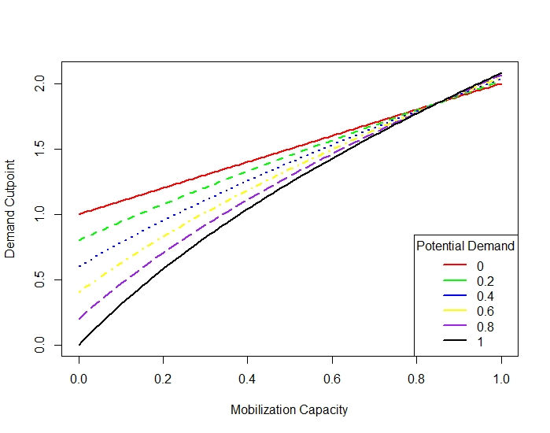
Figure 1 - d* as a function of the Other Group’s Mobilization Capacity
For any given line in Figure 1, the space above the line represents a situation where the government will set n = n*, repressing the active group to the point where they will back down. The space below the line represents situations where the government will set w = w*, fully repressing the potential group but allowing the active group to mount a challenge. Thus, if the active group has a demand d that is above a line the government considers it threatening enough to fully repress, and if it has a demand d that falls under the line the government will focus its attention elsewhere.
Figure 1 demonstrates an interesting relationship between the potential group’s mobilization capacity and the government’s willingness to repress the active group fully. We can see that an increase in the potential group’s mobilization capacity there are fewer demands by dissident groups (d_{A}) that would cause the government to repress the active dissident group. This then leads to my first implication:
Implication 1: As the potential group’s mobilization capacity increases, the government is less likely to repress the active group to the point of backing down, all else equal.
Figure 2, meanwhile, looks at how the cutpoint changes with respect to the potential group’s potential demand – the benefit they receive from mobilization and the costs the government faces from successful mobilization. The Figure is read the same way as Figure 1: area above a line represents equilibrium space where the government represses the active dissident group (by setting its expenditures on deterrent repression n = n*), and area below it represents equilibrium space where the government represses the potential group (by setting w = w*). This Figure demonstrates an interesting interactive effect between the potential group’s demand and capacity – at high levels of mobilization capacity increases in the potential group’s demand make it less likely that the government will set n = n*, but at low levels of capacity increases in the potential group’s demand make it more likely that the government will set n = n*. This leads to my second set of implications:
Implication 2a: At high levels of mobilization capability, increases in the potential group’s demands make the government devote fewer repressive resources to the active group and more towards the potential group.
Implication 2b: At low levels of mobilization capability, increases in the potential group’s demands make the government devote more repressive resources to the active group and fewer to the potential group.
These implications demonstrate that the government is thinking differently about the dimensions of threat. Increased dissident capability seems to be threatening to the government no matter the demand attached to it, while demand appears to be differentially threatening depending on the capabilities around it. In the model, this is due to the construction of the different dimensions – capability influences the probability of success, while demand is the additive cost to the government of dissident success. Thinking in terms of expected utilities, the expected utility for the government of losing to a highly capable group with a moderate demand is much lower than the expected utility of losing to a group with extreme demands but without a low capability. Outside of the context of the model, this difference makes sense – demand should matter to governments, but only if the governments believe the group can follow through and accomplish their goals.
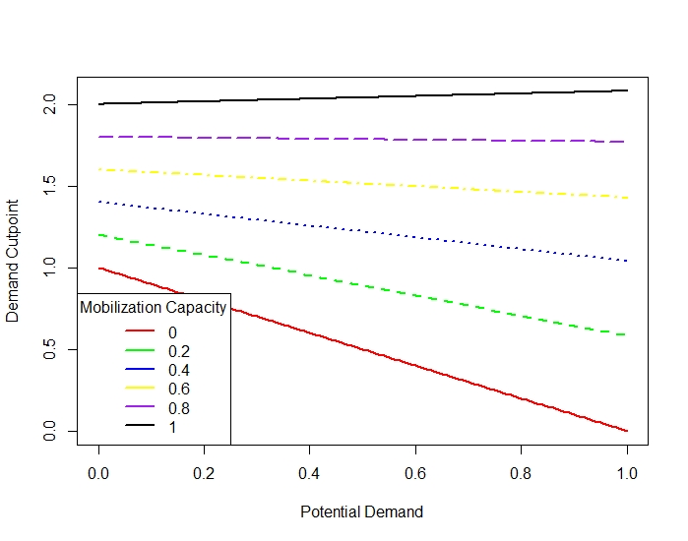
Figure 2 - d* as a function of the Other Group's Potential Demand

Scenario 4: Scarce Resources
In the final scenario, the government’s resources are severely restricted – it no longer has the resources to repress either group to the critical point. Formally, this can be expressed as s < n* + w*, s < n*, and s < w*. Since there is no way the government can reach the groups’ critical points, the government invests its resources to maximize its full conflict utility. Under these conditions, the government maximizes its utility by setting n = n’’ and w = w’’. Assuming the government has enough resources to hit these points, there is an equilibrium where the government sets n = n’’ and w = w’’, the active group dissents, and the latent group attempts to mobilize. If, however, the government does not have enough resources to reach these values, the government must decide where to allocate its entire repressive budget. In this scenario, one of the groups is going to be unrepressed, allowing it to operate with impunity. The government will invest everything in reactive repression (that is, n = s) if l, the change to the status quo if the potential group mobilizes, is sufficiently low: $l≤\left(-1-q\right)\left(m+s\right)$. Otherwise, it will invest everything in preventive repression (w = s). Regardless, the active group will dissent, and the potential group will attempt to mobilize. In Figure 3, below, the top row of graphs show how n’’ change with respect to the potential group’s mobilization capacity and potential demand, respectively; the bottom row show the same but for w’’. These graphs indicate an unsurprising trend: as the potential group gets more threatening, the government sets a lower n’’ and a higher w’’. As the potential group becomes less threatening, we observe the inverse.
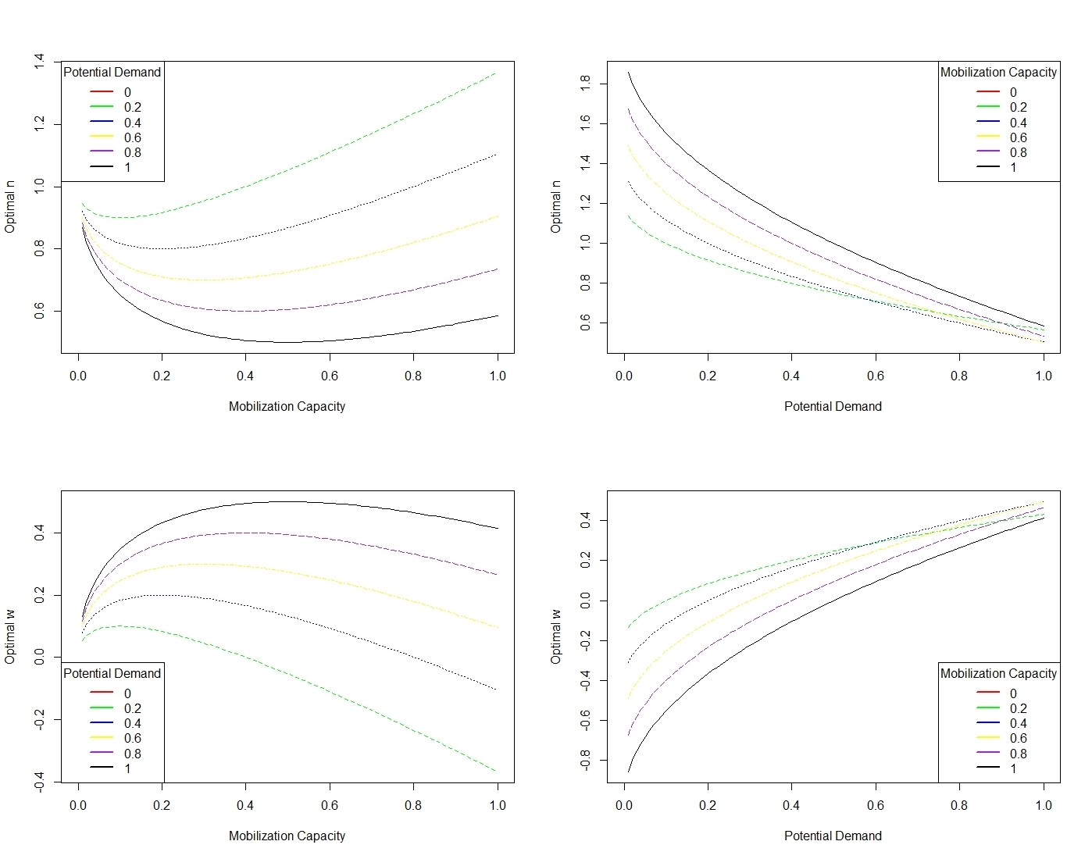

Figure 3 – Optimal n’’ and w’’ as a function of the Other Group’s Demand and Capacity

Empirical Implications
The model gives us several implications that can be translated into testable, empirical hypotheses. Note that the implications listed below are particular to states with moderate repressive capacity. As discussed above, these implications arise from the scenario where the government has dwindling resources for repression – they have enough resources to repress one group to the point they back down, but not both. This resource scarcity is what drives the shift in repression; if the government had abundant resources, it would simply repress everyone (i.e., the first scenario).
Implication 1 states that as the potential group’s mobilization capacity increases, the government should be less likely to repress the active group to the point where it will back down. This tipping point for the active group can be thought of as severe repression – targeting enough repression at the group to get it to back down. From this implication, we get my first hypotheses:
Hypothesis 1: As the Other Group’s Capacity increases, the severity of repression faced by the Active/Target Group decreases.
The second set of implications states an interactive relationship between the potential group’s capacity and demand: at high levels of capacity increases in demand lead to a decrease in the probability that the government sets n = n*, but at low levels of capacity increases in demand lead to an increase in the probability that the government sets n = n*. Again, thinking about that tipping point as the severity of repression faced by the active/target group, we get the following set of hypotheses:
Hypothesis 2a: At high levels of Other Group Capacity, increases in Other Group Demand will result in a decrease in the severity of repression faced by the Active/Target Group.
Hypothesis 2b: At low levels of Other Group Capacity, increases in Other Group Demand will result in an increase in the severity of repression faced by the Active/Target Group.

Data
The predictions generated by the theoretical model require specific information about the characteristics of dissident groups and the government’s response to them. I also need to be able to assess the number of active dissident groups in a given country at a given time. With these data needs in mind, I utilize the Minorities at Risk Organizational Behavior (MAROB) dataset (Wilkenfield, Asal, & Pate 2011). Coded at the organization-year level, this dataset looks at ethnopolitical groups in the MENA region from 1980 – 2004. Each of the organizations in the dataset is trying to forward the interests of a particular minority group in a given country. The dataset records various important characteristics about the groups, including information about the organization’s leadership structure, specific demands, their tactics, and their relationship to the state.

Organization-Level Variables
Recall that the main variable of interest is the share of the repressive budget that the state devotes to each organization. While there is not a perfect analog for this in the MAROB data, there is data on how the state treats the group. The variable “STORGREPRESS” looks at the state’s relationship with the organization in a given year, ranging on a score from 1 to 5. The categories are somewhat ordinal, with a “1” representing an organization that is legal, a “2” representing an organization that is legal but subject to periodic repression, a “3” denoting an organization that is illegal but tolerated, a “4” denoting an illegal organization that is subject to periodic repression, and a “5” representing an organization that is both illegal and is targeted for ongoing repression. I recode this variable so there are three main groups: groups that are tolerated by the state (the “1”s and “3”s), those that are subject to periodic repression from the state (the “2”s and “4”s), and those that are targeted for ongoing repression by the state (the “5”s). I assume that as an organization moves from a 1 to a 2 to a 3 it is receiving a higher share of the repressive budget, while those decreasing on the scale are likely accounting for a smaller share of the repressive budget.
I’m also interested in the threat posed by each organization to the government – the group’s demand and capability. I conceptualized the group’s demand as how much they desire to change the status quo. Mapping a measure of demand directly onto the conceptual definition would require very fine-grained data about the specific policies that make up the current status quo and information on how the group plans to change these policies, but we can approximate this using MAROB’s data on group ideology. MAROB codes the organizations on various dimensions: whether they’re religious, economically left- or right-wing, their relationship to gender, etc. Most of these would require some knowledge about how these dimensions relate to the state (i.e., whether the state is left- or right-wing, the current regime type, whether there is a state religion, etc.), but there is one that should generalize to all states over time. The “NATORG” variable looks whether the organization in question in nationalist – whether the organization is claiming autonomy or independence for a particular minority group. Assuming all states value territorial integrity, we can consider nationalist groups to be “high demand” groups, while non-nationalist groups are “low demand”.
Group capability is defined as the group’s ability to implement their desired change – the probability that they can coerce the government into enacting their demands. There are several standard ways of operationalizing this concept, ranging from looking at the membership of the group to the tactics they use. While these are useful operationalizations, they come with some caveats – “membership” doesn’t always translate into capability (it can be difficult to mobilize a high number of people, and small groups can be effective at getting the government to change policies) and their tactics (particularly whether they are violent or nonviolent) do not always denote strength (for example, a group can turn violent because it feels it is strong enough to take on the state directly or because they are desperate). Instead, I operationalize the group’s capability as their organizational structure. Different organizational structures influence an organization’s ability to withstand repression, mobilize supporters, maintain operational security, etc. – all integral to their ability to affect change. I use MAROB’s “LEAD” variable for this, which looks at how centralized the group’s leadership is. A score of “1” denotes a group with competing leadership, a “2” refers to a group with weak or decentralized leadership, a “3” denotes a group with a strong ruling council, and a “4” represents a group with a strong single leader. It is difficult to say whether a group with competing leadership is more or less capable than a group with decentralized leadership, or whether a group with a strong single leader is more or less capable than a group with a strong ruling council. As such, I recode this into a “strong” variable – a group is “weak” if it scores a “1” or a “2” (its leaders are competing, or it is decentralized) and a group is “strong” if it scores a “3” or a “4” (it has a strong single leader or ruling council).
The combination of these two dimensions represents the overall “threat” a group poses to the government. We can use a group’s score on the two component variables to give us a rough approximation of their overall threat: a group that is not nationalist and has weak leadership is low threat, a nationalist group with weak leadership or a non-nationalist group with strong leadership is moderate threat, and a group that is nationalist and has strong leadership is considered high threat.
 | Capability
Demand | Strong Leadership | Weak Leadership
Nationalist | High Threat | Moderate Threat
Non-Nationalist | Moderate Threat | Low Threat

While this gives us a lot of information about what I will refer to as the “target group” (i.e., the group whose repression varies), but we also need to know about the wider threat environment – the characteristics of the groups around the target group. To do this, I first count the total number of groups active in a given country-year, including the target group. For example, say the target group of interest was the Turkish Republican Party in Cyprus in the year 1980. The first step is to count the number of groups active in Cyprus in 1980 – the target group itself, the Democratic People’s Party, the Toplumcu Kurtulus Partisi, the National Unity Party, and the Turkish Unity Party, bringing the total number of groups in Cyprus during 1980 to 5. We then subtract the target group from the total number of groups to get the number of other groups, or the number of groups that make up the threat environment. To get information on the demands and capabilities of these groups, we follow a similar process: count the number of nationalist groups/groups with strong leadership in a given country-year and subtract the target group from the total (assuming it is also nationalist/has strong leadership). This leaves us with counts of the number of other high demand and high capability groups active in a country-year.

State-Level Variables
While the organizations themselves are the main focus of the theory, the characteristics of the state play an important role. The state’s repressive budget is of particular interest, as higher budgets allow the state to repress with impunity, while lower budgets result in constraints that force the state to pick and choose between targets. Unfortunately, states have an incentive to keep their repressive budgets hidden – to hide their true repressive capacity from both the dissidents and the wider international community. There are a few ways we can try to approximate the government’s repressive capacity, however.
First, we might assume that the government’s military expenditures and personnel roughly correlate to its repressive capacity. A higher military budget allows the government to invest in technologies of repression, while a high number of personnel means the state can send more troops to deal with a given problem. I use data from Correlates of War Project’s National Material Capabilities dataset (Singer, Bremer, & Stucky 1972; Singer 1987) for information on these variables. I divide states into high-capacity states or low-capacity states depending on their scores for each of these variables: states at or below the 50th percentile on either measure (roughly $27 million dollars for military expenditure and 24,000 for personnel) are considered low capacity, while those above the 50% percentile are considered high capacity.
Another way of approximating repressive capacity is by looking at the state’s gross domestic product. In theory, the higher a state’s GDP, the more resources it can invest in repressing a target. I use data from the Penn World Tables dataset (Feenstra, Inklaar, & Timmer 2015) to measure GDP. I utilize the PWT’s measure of both expenditure-side and output-side real GDP to divide the states into low capacity and high capacity. Again, those at or below the 50th percentile (roughly $24 billion 2005 USD for both expenditure-side and output-side GDP) are considered low capacity, while those above the 50th percentile are considered high capacity.

Research Design
Since the main dependent variable in the analysis is discrete – the categoric level of repression faced by the target group – it would be inappropriate to use a linear regression. Each level represents increasing severity of repression, and it is unlikely that groups would be able to move directly from a score of “1” to a score of “3” without first being categorized as a “2,” which makes a multinomial logit/probit inappropriate. Moreover, being able to assess how the threat environment changes the probability of being in higher levels of repression speaks more directly to the predictions of the theoretical model. With that in mind, I use an ordered generalized probit model to look at the effect of the threat environment on target group repression.
The main independent variables in the analysis are the characteristics of the threat environment: the number of groups with high (nationalist) demands and the number of groups with high capabilities (strong leadership). Since the theory predicts differences in what we should expect the component to do on their own versus in conjunction with one another, I interact these two variables. Modelling the relationship in this way provides a rough idea of how threatening the environment is even if we cannot know the specific nature of the threats.
I include two important control variables in the analysis. The first is the indicator of target group threat. Recall that the theory predicts that the effect of the threat environment should be separable from the repression the group would face in the abstract – that is, repression based on the target group’s threat itself. By including the target group’s threat as a control, we can have more confidence that any changes we observe in the repression faced by the target groups are due to the threat environment, rather than their own characteristics. The second control variable I include is the 1-year lagged repression score. It is likely that the characteristics of the threat environment (the number of groups, their demands, their leadership) are at least a strategic response to the government’s use of repression previously. In addition, due to policy stickiness the level of previous repression also likely influences the current level of repression (Poe & Tate 1994; Poe, Tate, & Keith 1999) – an issue of autocorrelation.

Results
The theory predicts that changes to the characteristics of groups in the threat environment. Increasing capabilities resulting in the government shifting repressive resources away from the target group and towards the other groups in the environment. Increasing demand, on the other hand, increases repression faced by the target group when the other groups are low capability, but decreases repression faced by the target group when the other groups in the environment are capable. In addition, the model predicts that we should observe differential effects depending on the capacity of the government. Lower capacity governments scramble to find the biggest threat and do what they can with limited resources, while mid- to high-capacity governments have more leeway in how they deal with threats. To investigate this dynamic, I divide the military personnel and GDP samples into subsamples – one for low-capacity governments and one for high-capacity governments.
Table 1 (below) presents the results for the “military personnel” sample. The High-Capacity Model suggests, in line with expectations, that increasing the number of capable groups in the threat environment decreases target group repression – as the capability of other groups increases, it becomes less likely that target groups will clear the demand threshold needed by the government to allocate repression to them. We expect a decrease in target group repression on average, and this is what we observe. The results for other groups’ demands are a bit less clear. In line with expectations, increasing the number of high demand groups on its own (i.e., without a corresponding increase in the number of capable groups) increases repression on the target group. However, as the threat environment includes more groups that have both demand and capability (the interactive threat), the model predicts we should observe a shifting of repression away from the target groups (on average) and towards the other groups in the environment. Empirically, this would mean that the demand component of threat on its own should have a positive effect on target group repression, while demand combined with capability should decrease target group repression. While the model shows a positive relationship between target repression and other group demand on its own, it shows the opposite of the expected interactive effect.
The model for the Low-Capacity Sample presents a different story. None of the key independent variables are significant – in fact, the only variable that seems to influence a group’s level of repression today is their previous level of repression. While the theory does make some predictions about how low-capacity groups should try to balance their repressive budgets, it is also important to consider that these governments were unlikely to be able to invest heavily in repression to begin with, making any changes to their policy difficult to detect especially if they are moving resources away from one group and towards another.
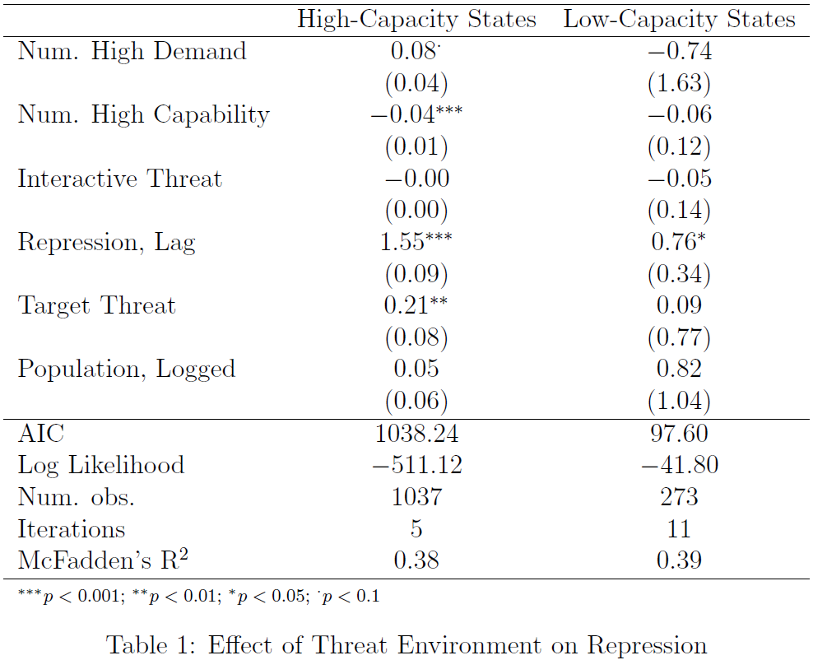

Discussion
To understand these empirical results, we must first return to the predictions of the model. Conceptually, we have broken threat into two main dimensions – demand and capability. The theory, and the results of the model, suggest that governments think about these dimensions as distinct from one another – changes to the capability dimension have different implications for repression than changes to the demand dimension. In addition, we also need to pay attention to the threat dimensions of the group the government is targeting and the dimensions of the other groups around. The dimensions of the other groups also factor into the government’s repressive decisions.
With these two points in mind, the model gives us the following predictions. First, increasing the capability of the other group in the threat environment decreases government repression of the target group. This is true regardless of the other group’s demand – whether they have low or high demands, increasing their capability makes them a more attractive target. Second, increasing the demands of the other group in the threat environment has differential effects depending on the other group’s capability. At high levels of capability, the government shifts resources away from the target group and towards this new, greater threat. At low levels of capability, however, increasing demand has the opposite effect – it causes the government to invest more in repressing the target group.
Given these predictions, we turn to the empirical results. As noted in the discussion regarding operationalizations, these measures are not perfect 1:1 representations of their concepts but they are close. Since the empirical world often has more (or less) than two dissident groups active at once, I try to take this into account by looking at the number of dissident groups that score highly on the demand and capability dimensions. The empirical results largely mirror the theoretical predictions, particularly regarding increasing capability. The results show that when we increase the number of capable groups in the threat environment, the repression faced by the target group decreases. This finding follows the logic of the theory – it is plausible that governments are pulling resources from the target group to put towards the more capable groups in the threat environment. The predictions for demand were less straightforward – the effect of demand is contingent on group capability. The empirical results seem to back this prediction up, at least somewhat: the main effect of increasing the number of high demand groups is increased repression on the target group, while the interactive effect of demand and capability is decreased repression on the target group. This is in line with theoretical predictions that state that increasing demand without increasing capability results in unbelievable threats, causing the government to shift its attention elsewhere.
The theory also predicts differences in repression based on the state’s capacity for repression. The model predicts that states with high repressive capacity should be able to repress with impunity – repressing every group to the point where the groups back down. Those states with more moderate resource endowments are forced to pick and choose their repressive targets – weighing the different threats against each other and allocating repression accordingly. Those in the moderate category likely have enough resources to repress effectively (i.e., they have enough resources to get some of the groups to back down), but they do not have access to the resources required to coerce every dissident group. Finally, those with low capacity are in a similar situation to the moderately endowed states, in that they attempt to prioritize their repressive efforts, but they lack the capacity to do so effectively.
The empirical evidence presented seems to back up these theorized differences. There appear to be significant differences in how the threat environment changes the activity of the high-capacity governments versus the low-capacity governments. I find that high-capacity governments show the expected trade-offs described above – they respond to increased capability in the threat environment by rerouting repression from the target group, and only respond similarly to increased demand in the presence of capability. The low-capacity states, on the other hand, are difficult to conclude anything about – nothing seems to significantly influence where they allocate repression. One possibility is that low-capacity states are truly different from moderate and high-capacity states in how they allocate repression, and this difference is neither captured by my theory nor my empirics. This is possible – there are always going to be omitted variables in any analysis – but finding a reason that explains why only the low-capacity groups would follow a different logic is difficult. Another possibility pertains to the nature of these states as “low-capacity”. These states, by (conceptual) definition, lack the resources to repress groups to the point where they back down. Empirically, this would likely manifest in one of two ways. First, they might not be able to put forward much of a repressive effort at all, and so they simply spread whatever repression they have around. This might explain why the dimensions of threat don’t seem to have much an effect – these states are instead trying to spread repression around equally, as everyone is a threat to them. The second possibility is that these states do follow the logic laid out in the theory, but their lack of resources makes it difficult to pick these trends up empirically. Their general lack of resources would make any shift of resources tiny, especially in comparison with the better equipped states, leading to small effects functionally indistinguishable from noise.
Finally, a note about the effect sizes reported in the models. A reasonable criticism of the results would note that the effect sizes are small – while the coefficients are significant, their effect on the government’s use of repression seems to be minimal. This is a result of the way the different variables are constructed – we’re observing the result of a one group increase on a rough measure of repression, so the effect sizes are bound to be small. The gap between a score of 1, 2, or 3 on repression is likely very wide, meaning the addition of a single group to the threat environment is unlikely to have a huge effect. Even with the small effect size, however, we still observe a statistically significant change in the way repression is being applied due to these threat dimensions.

Conclusion
Taken together, the theory and empirical results suggests that the interactions between governments and dissident groups are more complicated than they first appear. Far from being dyadic, they involve multiple actors with multiple considerations. First and foremost, governments are cognizant of the threat environment when deciding on repressive actions. Theoretically, the government is trying to maximize its repressive dollar by picking and choosing between the different threats. Empirically, governments are reacting to changes in the threat environment, shifting their repressive resources around as the threat environment changes. Second, the theoretical definition of “dissident threat” seems to have some purchase in the empirical world, as governments react to the different dimensions of threat in different ways. Governments are more willing to shift repressive resources away from a target when new capable groups enter the threat environment but are more hesitant to make this shift when only more demanding groups enter the environment. Finally, government capacity matters when we’re considering the government’s response to dissident threat. Governments with an abundance of repressive resources can move them around in response to changing threat environments, while poorer states have a much more difficult time doing so.
All of these findings have implications for how we should think about the repression-dissent nexus going forward. The first thing we need to acknowledge is that repressive decisions are not a product of the actions and characteristics of a single group. Instead, they are an amalgam of government capacity, group characteristics, and the shape of the threat environment. Social scientists looking to understand repression should take these factors into account, particularly the threat environment. The characteristics of the individual groups do influence the government’s repressive behavior, but this study also shows that the government is considering the wider threat environment when making these decisions as well. To understand the true effect of group characteristics, we need to separate their effect at the group level from the effect of the threat environment, otherwise we run the risk of conflating these group characteristics with the government’s reaction to the wider universe of groups.
The concept of the threat environment offers several new research areas for scholars of repression and dissent. The theory I present here is a simple one – an interaction between one government and two dissident groups. As the empirics show, however, there are potentially many more groups active at any given time. These groups all make demands on the government’s time and resources, which have implications for the government’s application of repression and the actions of the other groups. Moreover, the model presented here has no interaction between the groups; the only way they influence each other is through the government’s use of repression. We know in the real world, however, that groups often work with (or against) each other. Each group is making separate demands on the government – sometimes these demands align and prompt cooperation, and sometimes these demands are at odds, prompting conflict. Entrance into the arena of contentious politics is endogenous, as well. Fledgling groups are watching the actions of the established groups and how the government responds to them. Their decision to attempt mobilization is almost certainly influenced by how the government is treating the existing groups, especially ones with similar demands and capabilities. For example, they might observe the heavy repression similar groups are getting and decide to bide their time. They might observe a group with a similar goal doing very well and decide to join in (or free ride). They might observe a group with an opposing goal acting and decide to enter the threat environment to stop them, knowing that they risk the attention of the government. Existing groups are competing for support, making conflict during recruitment possible. Allying with existing groups runs the risk of making the coalition an attractive target for government repression. All these interactions – this threat network – have major implications for how we think about and study repression and dissent.

Bibliography
Amnesty International. 2020. “USA: Police Failing to Protect Protesters from Violence, as Volatile Elections Near.” Retrieved from https://www.amnesty.org/en/latest/news/2020/10/usa-police-failing-protect-protesters- from-violence/
Bob, Clifford and Sharon Erickson Nepstad. 2007. “Kill a Leader, Murder a Movement? Leadership and Assassination in Social Movements.” American Behavioral Scientist 50(10): 1370-1394.
Buchanan, Larry, Quoctrung Bui, and Jugal K. Patel. 2020. “Black Lives Matter may be the Largest Movement in US History.” The Washington Post. Retrieved from https://www.nytimes.com/interactive/2020/07/03/us/george-floyd-protests-crowd- size.html
Carey, Sabine C. 2010. “The Use of Repression as a Response to Domestic Dissent.” Political Studies 58: 167-186.
Chang, Paul and Alex Vitale. 2013. “Repressive Coverage in an Authoritarian Context: Threat, Weakness, and Legitimacy in South Korea’s Democracy Movement.” Mobilization 18(1): 19-39.
Chenoweth, Erica and Orion A. Lewis. 2013. Nonviolent and Violent Campaigns and Outcomes, v. 2.0. University of Denver.
Chenoweth, Erica and Orion A. Lewis. 2013. “Unpacking Nonviolent Campaigns: Introducing the NAVCO 2.0 Dataset.” Journal of Peace Research 50(3): 415-423.
Chenoweth, Erica and Jeremy Pressman. 2020. “This Summer’s Black Lives Matter Protesters Were Overwhelmingly Peaceful, Our Research Finds.” The Washington Post. Retrieved from https://www.washingtonpost.com/politics/2020/10/16/this-summers-black-lives- matter-protesters-were-overwhelming-peaceful-our-research-finds/
Christensen, Darin and Jeremy M. Weinstein. 2013. “Defunding Dissent: Restrictions on Aid to NGOs.” Journal of Democracy 24(2): 77-91.
Cunningham, David. 2004. There’s Something Happening Here: The New Left, the Klan, and FBI Counterintelligence. University of California Press.
Danneman, Nathan & Emily Hencken Ritter. 2014. “Contagious Rebellion and Preemptive Repression.” Journal of Conflict Resolution 58(2): 254-279.
Davenport, Christian. 1995. “Multi-Dimensional Threat Perception and State Repression: An Inquiry into Why States Apply Negative Sanctions.” American Journal of Political Science 39(3): 683-713.
Davenport, Christian. 2007. “State Repression and Political Order.” Annual Review of Political Science 10: 1-23.
Davenport, Christian, Sarah A. Soule, & David A. Armstrong II. 2011. “Protesting while Black? The Differential Policing of American Activism, 1960 to 1990.” American Sociological Review 76(1): 152-178.
Davenport, Christian and Molly Inman. 2012. “The State of State Repression Research Since the 1990s.” Terrorism and Political Violence 24(4): 619-634.
DeMeritt, Jacqueline H.R. 2016. “The Strategic Use of State Repression and Political Violence.” Oxford Research Encyclopedia of Politics. Retrieved from https://oxfordre.com/politics/view/10.1093/acrefore/9780190228637.001.0001/acrefore- 9780190228637-e-32
Earl, Jennifer, Sarah A. Soule, & John. D. McCarthy. 2003. “Protest under Fire? Explaining the Policing of Protest.” American Sociological Review 68(4): 581-606.
Escriba-Folch, Abel. 2013. “Repression, Political Threats, and Survival Under Autocracy.” International Political Science Review 34(5): 543-560.
Heffington, Colton. 2021. “External Threat and Human Rights: How International Conflict Leads to Domestic Repression.” Journal of Human Rights 20(1): 2-19.
Human Rights Watch. 2020. “US: New York Police Planned Assault on Bronx Protesters.” Retrieved from https://www.hrw.org/news/2020/09/30/us-new-york-police-planned- assault-bronx-protesters
Koren, Ore and Bumba Mukherjee. 2021. “Civil Dissent and Repression: An Agency-Centric Perspective.” Journal of Global Security Studies 6(3).
Moore, Will H. 2000. “The Repression of Dissent: A Substitution Model of Government Coercion.” Journal of Conflict Resolution 44(1): 107-127.
Pierskalla, Jan Henryk. 2010. “Protest, Deterrence, and Escalation: The Strategic Calculus of Government Repression.” Journal of Conflict Resolution 54(1): 117-145.
Regan, Patrick M. & Errol A. Henderson. 2002. “Democracy, Threats and Political Repression in Developing Countries: Are Democracies Internally Less Violent?” Third World Quarterly 23(1): 119-136.
Ritter, Emily Hencken. 2014. “Policy Disputes, Political Survival, and the Onset and Severity of State Repression.” Journal of Conflict Resolution 58(1): 143-168.
Ritter, Emily Hencken & Courtenay R. Conrad. 2016. “Preventing and Responding to Dissent: The Observational Challenges of Explaining Strategic Repression.” American Political Science Review 110(1): 85-99.
Ward, Alex. 2020. “The Unmarked Federal Agents Arresting People in Portland, Explained.” Vox. Retrieved from https://www.vox.com/2020/7/20/21328387/portland-protests- unmarked-arrest-trump-wold
Woodworth, Whitney and Virginia Barreda. 2020. “Salem Police Face Claims of Unequal Treatment of Black Lives Matter, Proud Boys Protesters.” The Statesman Journal. Retrieved from https://www.statesmanjournal.com/story/news/2020/11/29/salem-police- response-black-lives-matter-proud-boys-protests-criticized/3766157001/
Young, Joseph K. 2013. “Repression, Dissent, and the Onset of Civil War.” Political Research Quarterly 66(3): 516-532.

Given the nature of the Floyd protests, it is natural to assume that the differential treatment might be due to racial animus (i.e., the systemic police violence BLM is protesting is racially motivated). While this likely explains some of the differential treatment, it does not give us the whole picture. If this were the sole source of the differential treatment, we would expect police to be more selective in how they applied their repressive force – trying to specifically target minorities. Instead, what we observe is relatively indiscriminate repression applied to everyone on the BLM side, which is more in line with police being threatened by the content of the protests rather than the protesters themselves.
Even though the counter-protesters were ostensibly pro-status quo, they were a threat to the government and police. Depending on the location of the protest, the counter-protesters may have been at odds with the local government – some municipalities were considering changes to the way that the police were funded, putting them at odds with the demands of the counter-protesters.
Assuming the characteristics of the government do not change, as group “threat” is subjective to the government. Different governments have different ideal status quos and different abilities to weather the group’s coercive abilities, thus making it so the same group can pose a different level of threat to two different hypothetical governments.
It is important at this point to mention how the capacity of the state plays a role. In the formal model presented below, I assume that governments have limited repressive resources. However, the most powerful governments – the ones with high repressive capacity – are still able to repress every group. While they are aware of the differences between groups, their resources let them be functionally indiscriminate with their repression. We might make a similar argument about the United States as a whole – the federal government has more than enough resources at its disposal to repress whatever groups it desires. This is not true, however, on the state and local level: local police departments face resource constraints that force them to focus on specific threats. In this case, the individual police forces focus on the BLM protesters, knowing that the pro-police protesters are there (ostensibly) in support of them and the status quo. If the Proud Boys were more openly hostile to the police and the status quo, however, we would expect the police to respond to both groups with repression – comparing this counterfactual to reality, we’d expect the police to invest less resources in combating BLM and more into fighting the Proud Boys and other counter-protesters.
I assume that repression is effective in as far as reactive does raise costs for the group and preventive does make mobilization more difficult. I also assume that higher investments in repression lead to higher effectiveness.
Note that these two types of repressive spending are not equally efficient – stopping a group before it has a chance to form is better for the government than responding to the actions of a group. In the terms of the model, I assume that preventive repression influences the probability of successful group mobilization, while reactive repression takes the form of an additive cost on groups intending to act. Both strategies are effective in their unique use cases, but in a vacuum it would be more efficient for a government to invest everything in preventive repression and stop any group from forming in the first place.
In this model I am assuming that the government has a fixed budget that it can use for repression and that it must use all of it. The amount it invests in reactive repression and the amount it invests in preventive repression must sum to the total amount. Conceptualizing it this way highlights the trade-off that I believe is at the core of the interaction, but it does add artificiality – I am forcing the government to spend some amount on repression. While this is a strong assumption, it is not without some basis in reality. Governments often have budgets set out for specific purposes, and usually all of budget must be used or it might be reduced in the future. Combined with the fact that governments possess finite resources, this suggests there is at least some validity in conceptualizing the resource constraint in this way.
While this is written as following the active group’s dissent decision, it could happen at any time after the government makes its repressive decision.
It is assumed that the payoffs for the active and latent groups are independent of one another, in that the actions of one group does not influence the other outside of how they influence the government’s repressive decision.
See the Appendix for the exact definitions of these points.
See the Appendix for the exact definition of these points.
There is information included about the group’s country of operation, but the data itself is organized at the organization-year level.
The limited timeframe, geographic scope, and political scope of the data does impose some restrictions on what we can conclude from the results. Namely, any results can only be said to apply to specifically ethnopolitical groups operating in the MENA region during the years 1980 – 2004. While this is an issue, it is a relatively minor one: these groups vary greatly in their structure, specific demands, popular support, etc., allowing us to make meaningful comparisons between the groups. Moreover, the region itself is quite heterogeneous, with states varying in terms of their GDP, military capabilities, and regime types.
The criteria required for inclusion into the data are as follows: “1) The organization makes explicit claims to represent the interests of one or more ethnic groups and/or the organization’s members are primarily members of a specific ethnic minority. 2) The organization is political in its goals and activities. 3) The organization is active at a regional and/or national level. 4) The organization was not created by a government. 5) The organization is active for at least three consecutive years between 1980 and 2006. 6) Umbrella organizations (coalitions/alliances) are NOT coded. Instead, member organizations are coded.” (MAROB Codebook Version 9/2008, 1).
The median value for this variable is a 1, and most organization-years are considered “low repression.” The frequency decreases from low to moderate to high repression, meaning that in most years organizations experienced relatively low intensity repression.
There are 112 organizations in the dataset, with 67 identified as “low demand” (non-nationalist), 44 identified as “high demand” (nationalist), and 1 unknown (nationalist stance is not identified – Iraqi Communist Party).
The extreme nature of this type of demand restricts us to comparing groups at the very high end of the demand continuum to all the other groups, but this in and of itself is a meaningful comparison, especially given the interactive nature of demand and group capability. Recall that the theory predicts states tend to ignore organizations with extreme demands but not the capability to back them up. Operationalizing group demand as their desire to secede is an extreme way to test this dynamic.
The assumption that decentralized groups are weaker than centralized ones is a strong one, but not without precedent. First, there is a specific definition for “weakness” in this case – “weaker” groups are ones unable to coerce the government. This process of coercion involves being able to weather adverse circumstances, like government repression, and their ability to effectively mobilize supporters and allies. Bob and Nepstad (2007) find that groups with established leadership structures and less factionalization are better able to deal with adverse events like the assassination of a leader.
I also construct versions of these variables that use the proportion of high demand and/or high capability groups in the threat environment. I take the counts produced using the above methods and divide them by the total number of groups in a country-year to get the proportions. Using these measures does not change the results in any meaningful way; see Appendix.
We could effectively think of the threat environment as a spatial weight (Beck, Gleditsch, & Beardsley 2006) – where the spatial distance between any two groups is a function of their state of operation and the characteristics of the threat environment. For example, two groups in the same country with a large number of high threat groups are going to be “closer” to each other than to a group in a different country with a similar number of high threat groups or to a group in the same country but at a different time when there were fewer high threat groups.
While military expenditure and the number of personnel provide us with good estimates of a state’s martial strength, this does not necessarily translate 1-to-1 into repressive strength (see, for example, Hendrix 2010). For example, having a large number of soldiers does not necessarily mean they are well-trained or well-equipped. Higher expenditure per soldier doesn’t necessarily translate into military effectiveness if the bureaucracy cannot get the money where it needs to go. On a more fundamental level, the government may not use the military to repress – they may instead delegate repressive responsibilities to local law enforcement. However, these measures do give us some insight into the government’s priorities re: coercive power, and the military can and has been used for repression in multiple countries.
Similar to the above military variables, GDP can be an effective measure of state capacity, but it has some important drawbacks. In theory, GDP is a straightforward measure of state power – increased GDP means that there are more resources to commit to policies like repression. In practice, however, we cannot assume that GDP immediately and always translates into repressive (or even military) might. Revenue takes time to turn into tangible resources – equipment must be bought, personnel trained, etc. Governments often have private information regarding their budgets, meaning that we cannot be sure how they are allocating their resources.
It should be noted that I chose a generalized ordered probit over a standard ordered probit due to the latter’s assumptions about the error terms across observations. Standard ordered probit/logit assumes homoscedastic errors across observations (Carroll 2018) – this is unlikely to be the case in observational data. Using a generalized model relaxes the assumptions regarding the error term, leading to less bias in the parameter estimates.
Note that I interact my variables to calculate group “threat” as opposed to make some sort of additive index. The reasoning behind this is two-fold – first, the component parts have interactive effects as well as main effects and second, we have little understanding how this index should be weighted. The theory predicts that both demand and capability have their own distinct effects on government repression in addition to interacting with one another; this is not something we’d be able to capture with an index. Second, it is unclear what weights, if any, should be applied to the index. We cannot say, based on the current theory, whether capability or demand are more important to the government let alone how much more important one is than the other.
I should note that these results should not be interpreted as causal. As with all observational data, there was no random assignment to the treatment group, and the current analyses do not attempt to correct for this statistically. As such, any results reported should be considered correlational.
Recall that at low levels of other group capability, increasing the other group’s demand lowers the demand cutpoint for the target group. This means that the government will repress target groups with less extreme demands when the other group has high demands and low capability. Empirically, we can think about this as a possibility for increased repression against the target group.
In addition to the Military Personnel sample, I also ran the same test on a divided GDP sample. As an additional robustness check, I also created proportional versions of the main independent variables. These results can be found in the Appendix.
It is worth taking the time to talk about why we might expect this differential response outside of the mechanics of the model. To do so, I borrow some ideas from the deterrence literature. This literature notes that for a threat to be deterrent, it needs to have two main components: it needs to be credible, and it needs to be capable. Credibility comes from the threat being in line with the threatening party’s preferences – the threat needs to be something the opposing force would do. Capability, on the other hand, comes from the belief that the threatening party can feasibly carry the threat out. We can apply these concepts here: for increased demands to be threatening to governments, the group needs to be credible and capable – the increased demand needs to be in line with their preferences and they need to have the ability to achieve it. In this way, making an increased demand without having the capability to back it up is like making a credible threat without capability – while the government may believe that the increased demand is in line with what the group has asked for, they believe they can safely ignore it because they believe that the group cannot accomplish something of the magnitude they are asking for. Alternatively, we might think of this as an economy of scale – as demands get bigger, the resources needed to extract them from the government get bigger. Increasing demand without capability is asking for the moon – the government knows the group won’t be able to get there themselves.
Note that this result holds when we run the model looking at the proportion of high capability groups in the threat environment as well. A reasonable argument against using the number of groups is that as the number of groups increases, there is greater strain on the government’s resources all around. This would make it easier to find evidence for decreases in target group repression – as the number of other groups increase, regardless of their characteristics, the repression faced by the target group will decrease because the government has fewer resources to devote to it. By looking at the proportion of groups in the threat environment, we can begin to address this concern.
Though there are arguments to be made for the non-linear effects of groups – i.e., the effect of adding an additional group to a threat environment that contains only one other group is likely going to be different from the effect of adding an additional group when there are already ten.

